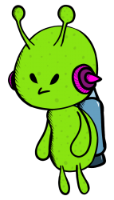

Paisley Invaders 2.5

Games Design Document

Group 2 - Gregor McFarlane, Sam Stewart, Ryan John Ritchie | Computer Games Development | 18/09/18

Contents

Game Design 2

Game Overview 2

Game Story 2

Unique Features 2

Pitch document – Game concept 3

Introduction 3

Storyline 3

Platform 3

Genre 3

Target audience 4

Unique selling points 4

Mood board 5

Character brief 6

Concept art 7

Analysis of influencing factors 9

Functional requirements 9

Design Approach 16

Stand ups 16

Pros of Agile development 16

Cons of agile development 17

Other development methods 17

Project Resources 17

Hardware 17

Software 17

External Media Resources 18

Information Sources 18

# Game Design

## Game Overview

Paisley Invaders 2.5 is a top down 3rd person perspective sci-fi shooter. The game is based on our group’s previous work on Paisley Invaders and Paisley Invaders 2. The original game was created as part of the bid for Paisley city of culture. The previous games were humorous and followed the story of famous people from Paisley on an epic adventure to defend against an alien attack. Throughout the previous games there was a cartoonish art style and simple 2D platforming gameplay. Paisley Invaders 2.5 is a sequel to Paisley invaders 2 but is not quite Paisley Invaders 3. We will continue to carry through the themes that makes our game unique, we will however, be completely changing the gameplay itself. With Paisley Invaders 2.5 we aim to go much bigger when it comes to actual gameplay.

## Game Story

You are Paolo Tennant, a brave defender of Paisley who is now on board an alien ship after defeating what he thought was the Alien leader. However, realizing he is trapped on board with plenty of aliens left, he must fight to find his way home.

## Unique Features

The game will feature third person perspective gameplay in which the player will need to traverse dangerous levels with deadly enemies.

There will be multiple enemy types to change the pace of gameplay and keep the player on their toes. During the first level the player will be introduced to the basic grunt enemy, then towards the end of the level the next enemy slightly more challenging than the last. As the levels progress more enemies will be introduced until finally they come face to face with the boss.

The environment will be on board an alien space ship. The ship will have open spaces, narrow corridors, explosive barrels and plenty of Paisley hating aliens.

There will be pick-ups in the game scattered throughout the levels such as ammo, health, and power-ups like a speed boost or a score multiplier. These pick-ups and power-ups will prove invaluable to the player as they venture through the game.

There will also be a score feature in the game allowing the player to rack up points by killing aliens and avoiding death as much as possible. The player will be able to save their score and view a local leaderboard showing the top 10 scores. The high score tables will be independent to each level and the player will have the ability to replay the levels to beat and set high scores.

The comedy aspect of the game will be another one of our unique features and we will try to have it persistent throughout the game.

# Pitch document – Game concept

## Introduction

“Zombie mayhem” is a cartoon style 2D side scrolling hack and slash game with elements of platforming. The game has an overall theme of an apocalyptic world overrun by zombies looking feast on any remaining humans.

## Storyline

The game takes play in the year 2020, at this point it has been a year since the zombie outbreak. The outbreak was caused by a strange meteorite that crashed on the planet’s surface. The player will play as “Steel” a human survivor who has crafted themselves a metal suit as protection from the seemingly endless hordes of zombies.

During the game the player will have to traverse through the levels killing zombies in there way, collecting powerups and acquiring ingredients for a cure. If the player runs out of lives they will restart the level that they are on.

## Platform

The game will be created for Windows on PC and will be played using the mouse and keyboard. However, it will also support an Xbox controller.

## Genre

The game will be a 2D hack and slash game with a cartoonish style and elements of platforming. The game will resemble 2D side scrollers as the player will start at the left of the screen/level and continue to move right until they reach the end of the level. This will be easy for players of all ages to understand and will ensure no one gets lost.

The controls will be as simple as possible;

* Keyboard – A and D will be used to move left and right like typical PC games whilst the space bar will be used to jump. The K key will be used to attack and P will be used to pause.
* Xbox controller – if using a controller, The A button will be used to jump and the left analog stick will be used for movement such as walking left and right. The X button will be used for attack and the ‘start’ button will be used as pause.

Move right

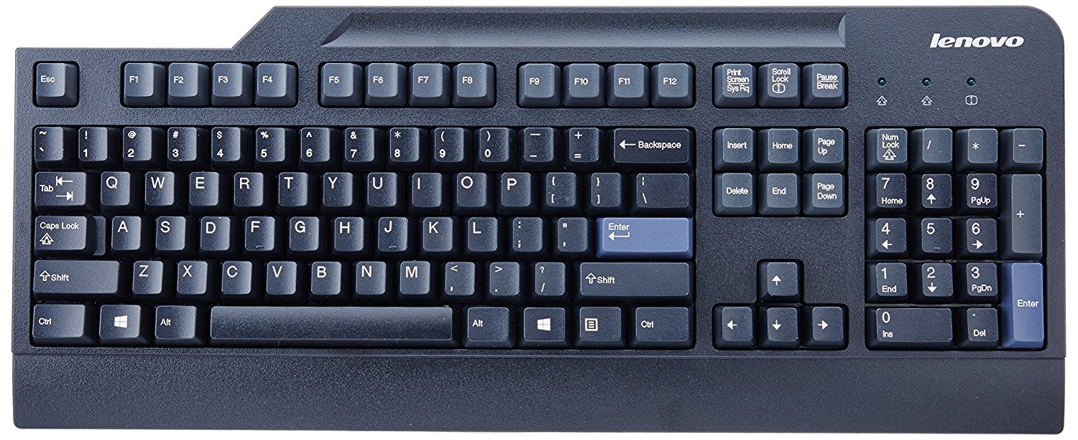

Move left

Attack

Jump

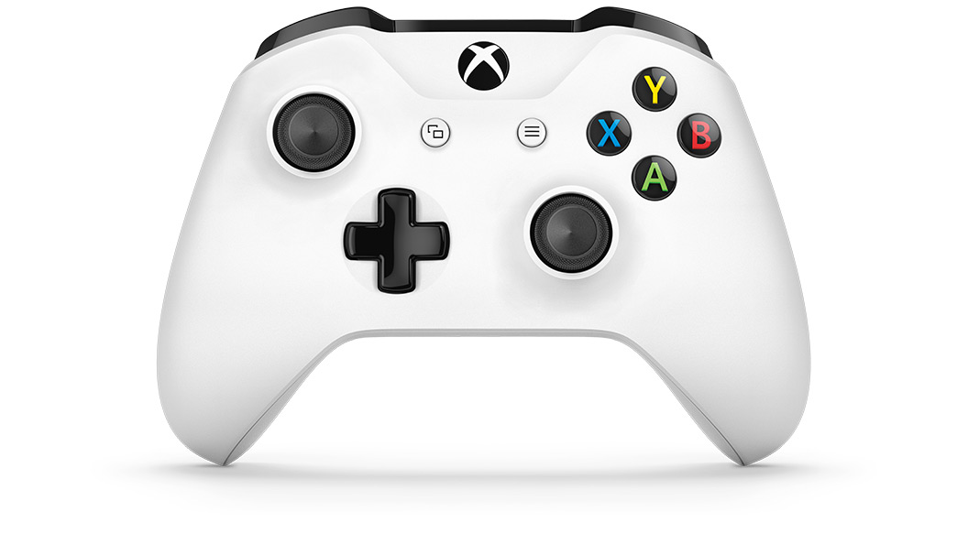

Jump

Attack

Move left and right

## Target audience

This game is targeted at people from the age of 9 to 35 as this age range are more likely to fans of the zombie genre than anyone older or younger. This game is also targeted towards people who are fans of 2D side scrollers and Zombie games. The is targeted towards the more casual gamer as it is relatively simple and not extremely challenging.

## Unique selling points

* A cartoon art style with fun characters and enemies.
* A fun and intriguing setting.
* Light hearted and colourful.
* A mix of platforming and hack and slash gameplay.

## Mood board

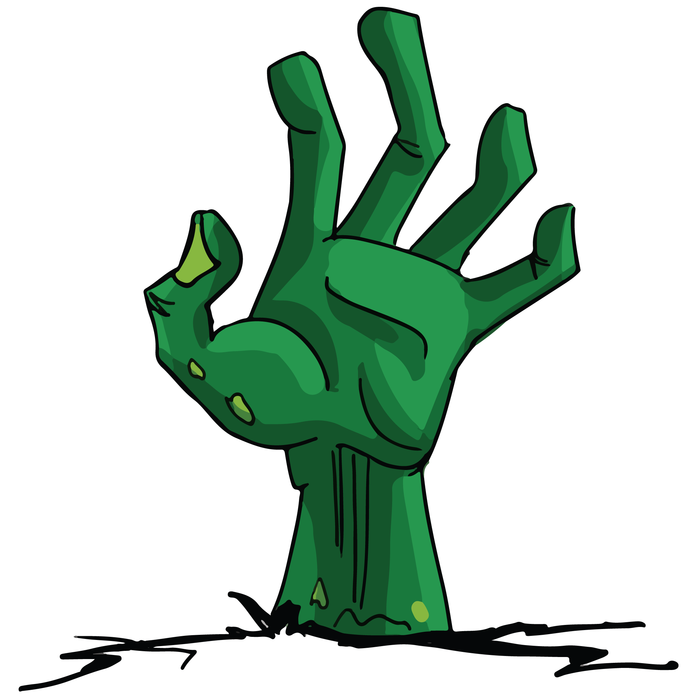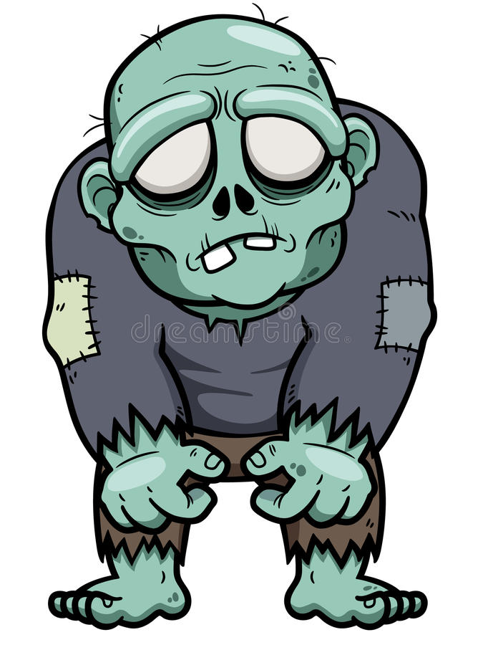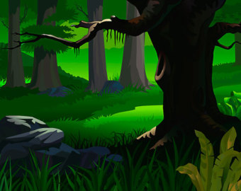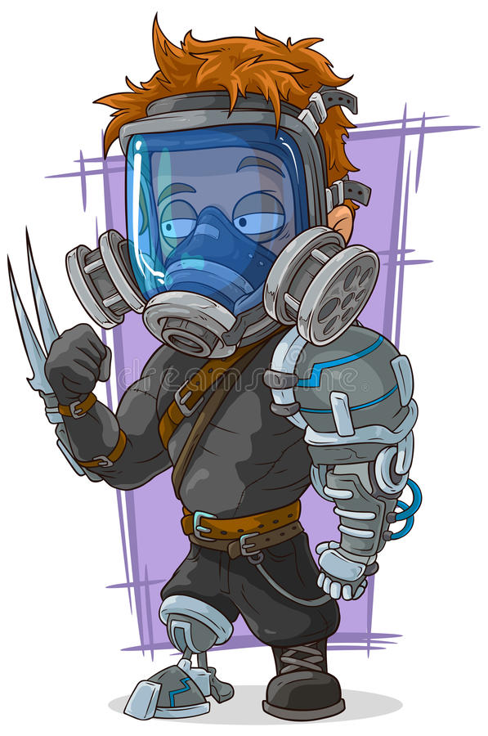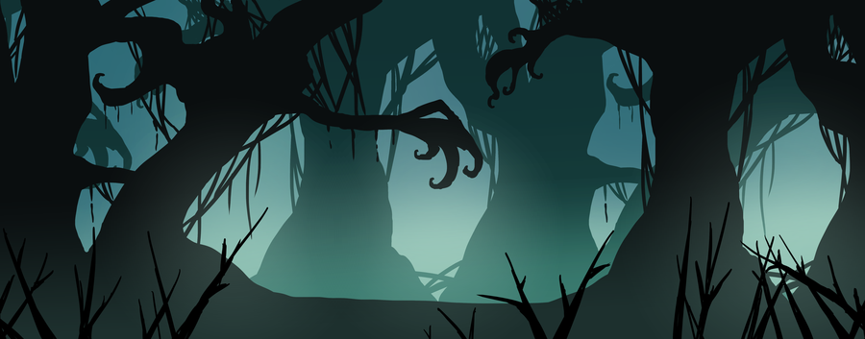

## Character brief

Nickname: Steel

Estimated age: 40

Background: Steel was ex special forces with a natural talent for building things out of scraps he could find. He was resourceful and liked to tinker with gadgets he’d make in his spare time. When Steel was in the special forces he was part of a task unit that would respond to chemical attacks, this meant he worked hands on with countless different countermeasures such as airborne vaccines to cure illnesses or infections. When the zombie outbreak hit Steel immediately started working on a plan. He would develop a cure and find a way to distribute it, saving millions of people and stopping the virus in its tracks. He also contrasted himself a suit of armour that would allow him to go outside in search of any supplies or resources he might need.

## Concept art

Main character “Steel”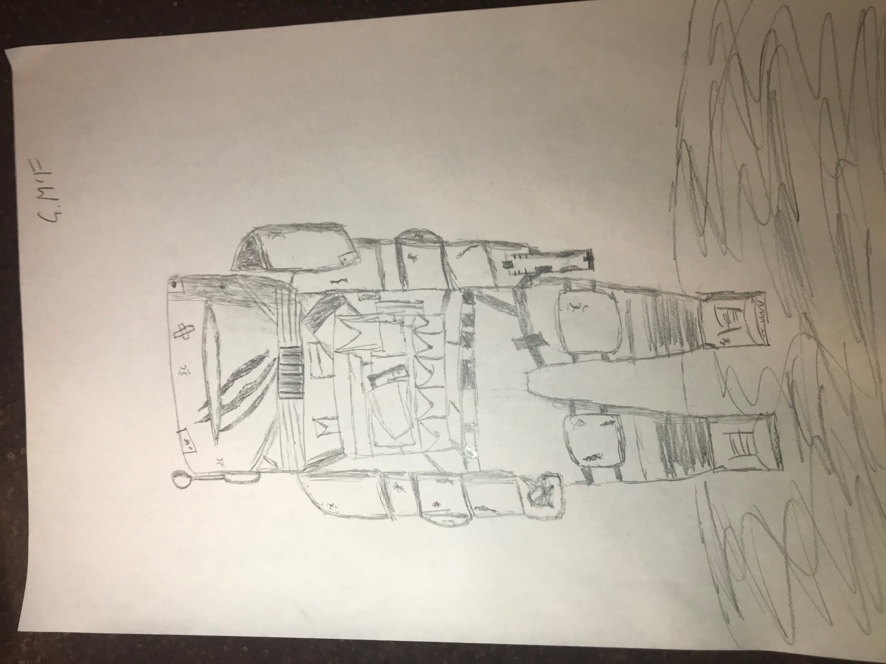

Level design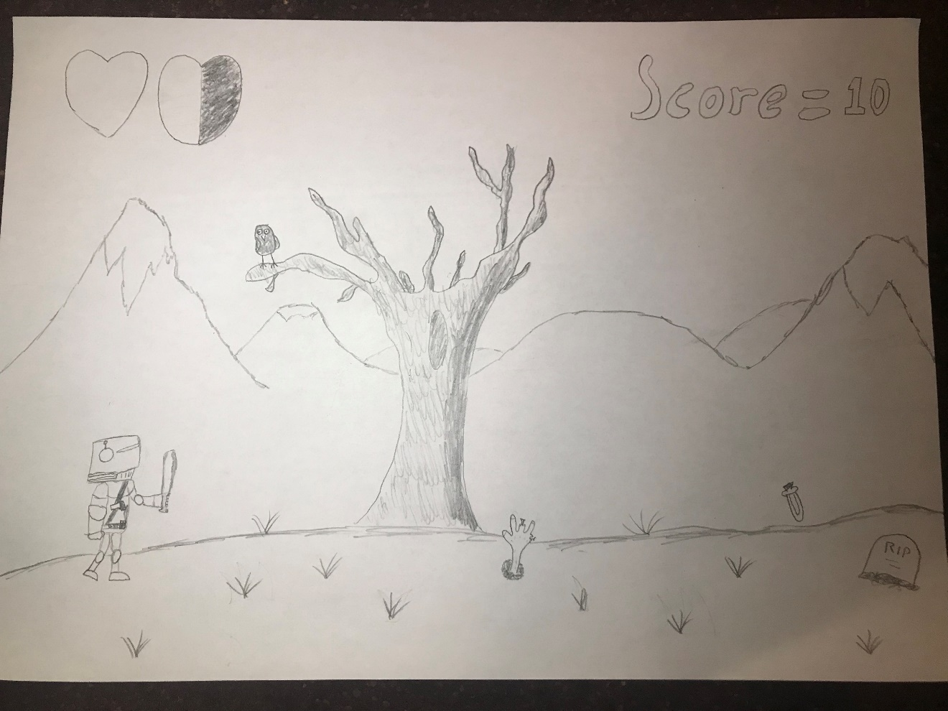Main menu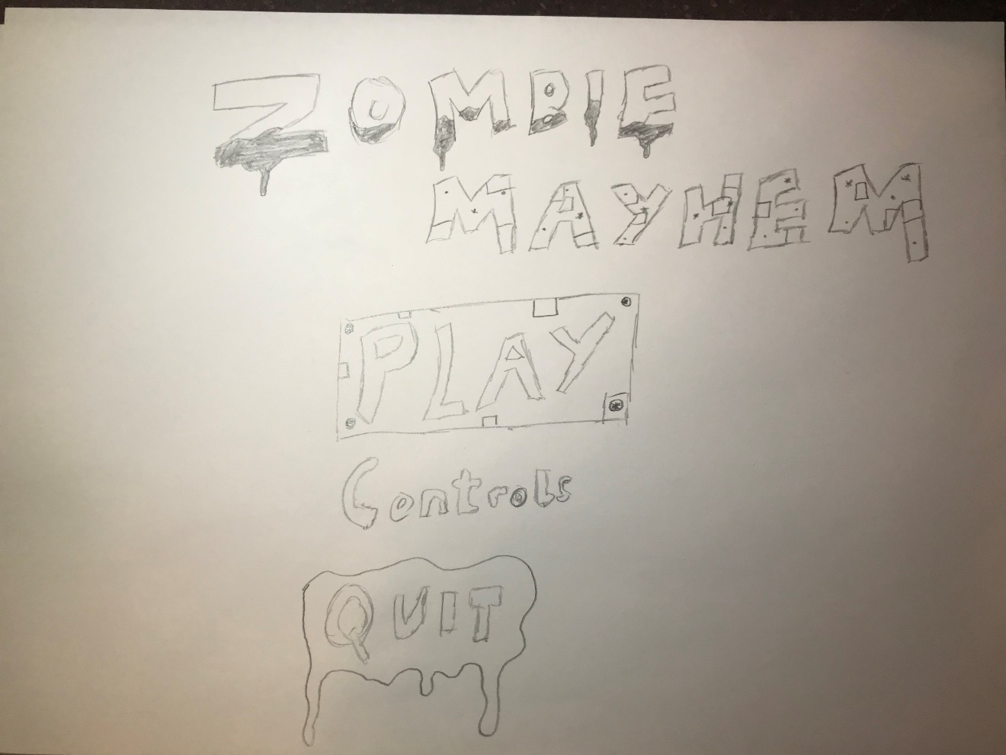

# Analysis of influencing factors

During this portion of my report I will be identifying all of the requirements for my game, both functional and non-functional. First I will identify the requirements given in the project brief such as;

* The developed game must be functional and be able to be played.
* The developed game must be based on one of the themes provided in the given brief.

## Functional requirements

|  |  |
| --- | --- |
| **Requirement Specification** | |
| **ID No.:** | 001 |
| **Type:** | Functional Non-functional |
| **Priority:** | High Medium Low |
| **Description:** | The main character (Steel) must be controllable by the player. |
| **Reason/Source:** | To ensure the player can move the on screen character, left, right and jump. |
| **Behaviour (Functional)**  or  **Acceptable values (Non-functional)** | When the player presses the A key the character on the screen must move left until the player stops pressing that key. When the player presses the D key the character must move right until the player stops pressing that key. When the presses the space bar the character must move up and then come back down to mimic gravity. |
| **Related documents** | Planning document |

|  |  |
| --- | --- |
| **Requirement Specification** | |
| **ID No.:** | 002 |
| **Type:** | Functional Non-functional |
| **Priority:** | High Medium Low |
| **Description:** | The game must have a functional menu system. |
| **Reason/Source:** | To allow the player to be able to start the game, exit the game, view the controls and view the high score table. |
| **Behaviour (Functional)**  or  **Acceptable values (Non-functional)** | If the player presses play, the game must start from the first level. If the player presses quit the game must shutdown. If the player presses controls the game must display the controls. If the player presses high scores the game must load the top 10 scores and display them in a table. |
| **Related documents** | Planning document |

|  |  |
| --- | --- |
| **Requirement Specification** | |
| **ID No.:** | 003 |
| **Type:** | Functional Non-functional |
| **Priority:** | High Medium Low |
| **Description:** | The player must be able to pick up the collectables in the game. |
| **Reason/Source:** | To allow the player to gain extra lives or boost their score. |
| **Behaviour (Functional)**  or  **Acceptable values (Non-functional)** | If the player moves the character over a collectable in the game, the collectable must be removed from the screen and the player must be given the benefit of that collectable. For example if it’s a health pick up the player will gain an extra heart. |
| **Related documents** | Planning document |

|  |  |
| --- | --- |
| **Requirement Specification** | |
| **ID No.:** | 004 |
| **Type:** | Functional Non-functional |
| **Priority:** | High Medium Low |
| **Description:** | The game must have multiple levels. |
| **Reason/Source:** | This is to keep the player’s attention and not make the game too short or boring. |
| **Behaviour (Functional)**  or  **Acceptable values (Non-functional)** | For example If the player finishes the first level the second level should start. This should have a different environment and harder enemies to change the pace of the game and keep the gameplay fresh. |
| **Related documents** | Planning document |

|  |  |
| --- | --- |
| **Requirement Specification** | |
| **ID No.:** | 005 |
| **Type:** | Functional Non-functional |
| **Priority:** | High Medium Low |
| **Description:** | The enemies should move towards the player and attack them. |
| **Reason/Source:** | To add challenge to the game and not make it too easy. To make the player want to beat the level. |
| **Behaviour (Functional)**  or  **Acceptable values (Non-functional)** | When the player gets within a short distance of the enemies they should follow the player. If the enemies come into contact with the player’s character they should attack and the player should loose health. |
| **Related documents** | Planning document |

|  |  |
| --- | --- |
| **Requirement Specification** | |
| **ID No.:** | 006 |
| **Type:** | Functional Non-functional |
| **Priority:** | High Medium Low |
| **Description:** | The game must have a high score system |
| **Reason/Source:** | To allow the player to view the top 10 scores of people that have played the game. |
| **Behaviour (Functional)**  or  **Acceptable values (Non-functional)** | If the player achieves a high score, when they die or finish the game the game should allow them to enter their initials with up to 3 characters total. The game should then save and store their score. If the player views the high score table the game should display the top 10 scores along with the initials of each player. After more than 10 scores the game should delete any others. |
| **Related documents** | Planning document |

|  |  |
| --- | --- |
| **Requirement Specification** | |
| **ID No.:** | 007 |
| **Type:** | Functional Non-functional |
| **Priority:** | High Medium Low |
| **Description:** | The player must start with 3 lives and 0 score. |
| **Reason/Source:** | To keep the game fair each time it is played. |
| **Behaviour (Functional)**  or  **Acceptable values (Non-functional)** | If the player starts the game or a new level their lives should be set to 3. If the player starts a new game their score should be set to 0. However, if the player finishes a level and progresses onto the next their score from the last level must carry over. |
| **Related documents** | N/A |

|  |  |
| --- | --- |
| **Requirement Specification** | |
| **ID No.:** | 008 |
| **Type:** | Functional Non-functional |
| **Priority:** | High Medium Low |
| **Description:** | The game must be playable with a controller. |
| **Reason/Source:** | To allow the player the option to play with either a keyboard or controller. |
| **Behaviour (Functional)**  or  **Acceptable values (Non-functional)** | All of the games actions and options must be mapped to a controller as well as a keyboard and must be fully functional. When a player presses a button on the controller the game must recognise it the same way it would on the keyboard and perform the requested action. |
| **Related documents** | Planning document |

|  |  |
| --- | --- |
| **Requirement Specification** | |
| **ID No.:** | 009 |
| **Type:** | Functional Non-functional |
| **Priority:** | High Medium Low |
| **Description:** | The game must have at least 4 different sound effects. |
| **Reason/Source:** | To make the game more immersive and fun. To enhance the quality of the game and let the player know audibly the action has happened. |
| **Behaviour (Functional)**  or  **Acceptable values (Non-functional)** | For example if the player picks up a collectable a sound effect will play to let the player know that the action has taken place. Or if the player takes damage a sound effect will take place of a grunt to let the player know their character has been hit. |
| **Related documents** | N/A |

|  |  |
| --- | --- |
| **Requirement Specification** | |
| **ID No.:** | 010 |
| **Type:** | Functional Non-functional |
| **Priority:** | High Medium Low |
| **Description:** | The player must be able to attack and kill zombies. |
| **Reason/Source:** | To allow the player to be able to finish the game and earn a high score they must be able to kill enemies. |
| **Behaviour (Functional)**  or  **Acceptable values (Non-functional)** | For example if the player presses K they will shoot a bullet. If the bullet hits an enemy the bullet and enemy will be removed from the screen and the player will earn points towards their score. |
| **Related documents** | Planning document |

|  |  |
| --- | --- |
| **Requirement Specification** | |
| **ID No.:** | 001 |
| **Type:** | Functional Non-functional |
| **Priority:** | High Medium Low |
| **Description:** | The game must have an apocalyptic theme. |
| **Reason/Source:** | The games theme must correspond with one of the themes in the given project brief. |
| **Behaviour (Functional)**  or  **Acceptable values (Non-functional)** | Must have fitting graphics and sound effects to keep the theme continuous throughout all elements of the game. The Character’s and enemy’s graphics also must fit the theme of the game. |
| **Related documents** | N/A |

|  |  |
| --- | --- |
| **Requirement Specification** | |
| **ID No.:** | 002 |
| **Type:** | Functional Non-functional |
| **Priority:** | High Medium Low |
| **Description:** | The game and all documentation must be finished and handed in for the 6th of June. |
| **Reason/Source:** | To allow meet the deadline of the project and allow it to be assessed and marked. |
| **Behaviour (Functional)**  or  **Acceptable values (Non-functional)** | I must follow my detailed play and ensure I am meeting my deadlines in plenty of time. I must work hard and to the best of my ability to complete the project within the given time. |
| **Related documents** | N/A |

|  |  |
| --- | --- |
| **Requirement Specification** | |
| **ID No.:** | 003 |
| **Type:** | Functional Non-functional |
| **Priority:** | High Medium Low |
| **Description:** | The game must follow my detailed plan and be as accurate to my concept as possible. |
| **Reason/Source:** | To achieve a high grade and meet the requirements of the specification. |
| **Behaviour (Functional)**  or  **Acceptable values (Non-functional)** | I must stick with everything I have planned out and try to keep my game as close to my original concept as possible. I must do the tasks I have set myself to do and on the dates I have set to do them. |
| **Related documents** | Planning document |

|  |  |
| --- | --- |
| **Requirement Specification** | |
| **ID No.:** | 004 |
| **Type:** | Functional Non-functional |
| **Priority:** | High Medium Low |
| **Description:** | The game must be appealing to the target audience. |
| **Reason/Source:** | I have chosen my theme and stated the target audience so therefore I must ensure my game not only meets the project criteria but also stays true to the target audience. |
| **Behaviour (Functional)**  or  **Acceptable values (Non-functional)** | I must ensure my environment, gameplay and assets are all appealing to the zombie/apocalyptic fan base that I am targeting. I must not stray away from my theme as my game would no longer be interesting my target audience. |
| **Related documents** | Planning document |

|  |  |
| --- | --- |
| **Requirement Specification** | |
| **ID No.:** | 005 |
| **Type:** | Functional Non-functional |
| **Priority:** | High Medium Low |
| **Description:** | The game must be simple to use and play yet still maintain a small amount of challenge. |
| **Reason/Source:** | To ensure that the player can pick up the game easily but don’t get bored of it quickly or find it too easy. |
| **Behaviour (Functional)**  or  **Acceptable values (Non-functional)** | I must ensure that the controls are simple and easy to use but the enemies get progressively more difficult. |
| **Related documents** | Planning document |

|  |  |
| --- | --- |
| **Requirement Specification** | |
| **ID No.:** | 006 |
| **Type:** | Functional Non-functional |
| **Priority:** | High Medium Low |
| **Description:** | The game should be completed to a high quality. |
| **Reason/Source:** | To achieve a good grade in my graded unit and to meet the requirements of my specification. |
| **Behaviour (Functional)**  or  **Acceptable values (Non-functional)** | I will need to work hard, maintain a positive attitude and follow my detailed plan to ensure my end product is finished on time and to a high standard. |
| **Related documents** | Planning document |

|  |  |
| --- | --- |
| **Requirement Specification** | |
| **ID No.:** | 007 |
| **Type:** | Functional Non-functional |
| **Priority:** | High Medium Low |
| **Description:** | Some time during the development stage must be used to go back and update animations or graphics created in the design stage. Time will also need to be used to create test plans and to test the game. |
| **Reason/Source:** | To ensure the game works smoothing and stays true to the theme and project brief. |
| **Behaviour (Functional)**  or  **Acceptable values (Non-functional)** | I will need to adhere to my detailed plan. I will need to be aware of my time and ensure I am leaving time for other tasks to be completed. |
| **Related documents** | Planning document |

|  |  |
| --- | --- |
| **Requirement Specification** | |
| **ID No.:** | 008 |
| **Type:** | Functional Non-functional |
| **Priority:** | High Medium Low |
| **Description:** | The game must be light hearted and colourful. |
| **Reason/Source:** | To ensure the game is not too gloomy and still appeals to younger fans of the apocalyptic genre. To ensure the game adheres to the project plan and game concept. |
| **Behaviour (Functional)**  or  **Acceptable values (Non-functional)** | Keep the graphics rich with colour and not too realistic or over detailed. Ensure any soundtracks are not too heavy or low mood. Try to make the game seem energetic. |
| **Related documents** | Planning document |

|  |  |
| --- | --- |
| **Requirement Specification** | |
| **ID No.:** | 009 |
| **Type:** | Functional Non-functional |
| **Priority:** | High Medium Low |
| **Description:** | The game to run smoothly. |
| **Reason/Source:** | To allow the player to play the game without the game lagging or its frame rate dropping too low. |
| **Behaviour (Functional)**  or  **Acceptable values (Non-functional)** | I will compress graphics and other media assets to ensure they take up less space. I will also keep my code clean and tidy. |
| **Related documents** | N/A |

|  |  |
| --- | --- |
| **Requirement Specification** | |
| **ID No.:** | 010 |
| **Type:** | Functional Non-functional |
| **Priority:** | High Medium Low |
| **Description:** | The game must run on a PC running windows 7 to 10. |
| **Reason/Source:** | To ensure the game meets the requirements of the specification.  To allow many people to be able to access the game and play it. |
| **Behaviour (Functional)**  or  **Acceptable values (Non-functional)** | I will create the game on unity and optimise it for PC use. |
| **Related documents** | Planning document |

# Design Approach

For my design approach I have chosen Agile development. This method will allow me to make changes to my project easily. More specifically I will be using the Scrum process as it will allow me to look back through my documentation and organize my next or future tasks. This will also allow me to run tests on my game without documenting them whilst I am in the development stage of the project, and then still be able to run planned and documented tests during the testing stage.

## Stand ups

Stand ups are commonly used during agile development where a team will discuss the plan of the day. However, since this is a solo project I will have no use for this, instead I will use this time to get started on my tasks as quickly as possible.

## Pros of Agile development

The advantages of using agile development is I am less restricted with my work. Agile development allows you to go back and make changes to previous things regardless of what stage you are currently on. If I was to choose waterfall development I couldn’t work on any other tasks until my current task is finished. However, with agile I can go back and fix an animation if it is causing difficulties with my coding or I can go forward and code a bit of the high score table before I finish coding the main menu. Another advantage of agile development is that since I can test my game undocumented frequently then I can spend less time testing in the testing section.

## Cons of agile development

The disadvantages to using agile is that I need to ensure my final product doesn’t stray from meeting the project requirements. Since I could be going back to fix previous things I could end up adding things to my game that I didn’t mention in the game concept. Even though I will try my best to stop this from occurring it’s possible that some aspects of my final game will be quite different from my original concept.

## Other development methods

One development method I had considered was the waterfall approach. Using this method, I would be able to focus my full attention to completing one task before moving onto the next. However, I realized this would prevent any flexibility or adaptions to my work which would most likely be necessary. Another development method I had considered was Rapid application development or RAD. With this process several tasks are worked on in parallel with each other, this would allow me to be working on two tasks at once. I had to rule this approach out as it is more of a team development process as tasks would be being created simultaneously.

# Project Resources

In this part of the report I will be stating the resources I will be using to produce my product.

## Hardware

* My personal laptop
* A college desktop PC
* An external hard drive
* An external USB drive

## Software

* Unity
* Adobe audition
* Adobe illustrator
* Google Chrome
* Spriter
* Microsoft Word

## External Media Resources

These links below are websites I will be using to acquire royalty free music and sound effects for my project.

* <https://www.zapsplat.com/>
* <https://musopen.org/>

# Information Sources

* <http://istqbexamcertification.com/what-is-rad-model-advantages-disadvantages-and-when-to-use-it/>
* <https://www.agilealliance.org/agile101/>